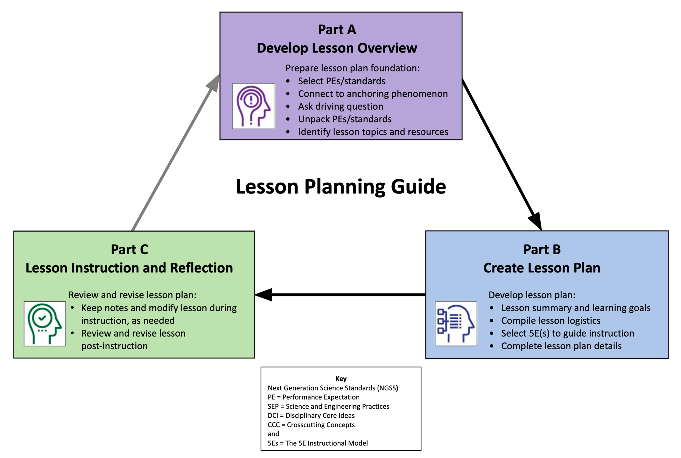

Lesson Planning Guide
Develop Lesson Plans for Instruction
Steps in developing NGSS-/standards-aligned, phenomenon-based lessons that are guided by the 5Es instructional model:
- Complete the Lesson Plan Overview (Part A) to guide development of lesson plans.
- Use the Lesson Plan Template (Part B) to create detailed lesson plans.

 | Lesson Overview Template (Part A)
1.a Select grade level NGSS Performance Expectations (PEs) or Topics, or district/state standards that support lesson-based student learning goals.
For NGSS, PE color coding reflects its 3-dimensional learning components. Search the Evidence Statements for details on what students should know and do.
Parkview Elementary School is a Science, Technology, Engineering and Mathematics positioned school in Chico, California. My class has twenty students. My chosen NGSS Evidence Statement is MS-ESS2-Earth Systems. Develop an emphasis on the processes of melting, crystallization, weathering, deformation, and sedimentation, which act together to form minerals and rocks through the cycling of Earth’s materials.
1.b Identify a lesson-based anchoring phenomenon that builds towards understanding of the PEs/standards, and is engaging and relevant to students.
See more about phenomena and using phenomena with NGSS.
Our anchoring phenomenon will be driven by routine measurable/visual observation of sand samples (weight, grain size, sphericity, color , possible source rock)
1.c Ask a Driving Question, which is authentic and student-focused, that relates to investigating the PEs/standards and phenomenon.
See more about Driving Questions and using Driving Questions with NGSS.
Given: Sand (photograph)collected by instructor from the Feather River Observed: Sand samples(photographs) from Science of Sand website
Query: Why isn’t all sand the same?
1.d Unpack the 3-D learning components of the Performance Expectations/standards in the table below.
For NGSS guidance, see the NGSS Topic Arrangements and NGSS DCI Arrangements. Use tools to unpack each PE separately.
Science and Engineering Practices (SEP)  (skills) |  | Disciplinary Core Ideas (DCI)  (content) | Crosscutting Concepts (CCC)  (connections)
Developing and using models:  Using simple tools and visual observations students will that mathematically interpreted measurements to first classify then discuss reasons for size difference and other properties of sand grains |  | ESSA.A: Earths Materials and Systems- The energy that flows and matter that cycles produces chemical and physical changes. Drive home relationship of kinetic energy of wind, rain flowing water as a form of energy capable of producing change in matter | Stability and Change  Explanations of stability and change in natural or designed systems can be constructed by examining the changes over time. Students will be able to explain what physical differences they noted and make knowledgeable inferences about why they think those differences exist

1.e Determine students’ prior knowledge about the lesson concepts. (e.g., pre-test, class discussion, exit ticket, 1-minute report, KWL chart, survey, etc.)
Class discussion will be primary method of interaction to determine prior knowledge, will utilize discussion to promote “parking lot’’ ideas formulated on a What I Know, What I Want to Know , What I Learned(KWL) chart for later review and incorporation into class
1.f Identify Lesson Topics and Learning Goals: List main lesson concepts related to grade level PEs/standards that support student learning goals in figuring out the anchoring phenomenon; revise as needed.
Incorporate mathematics, physics, information technology, visual and temporal learning skill development to have students understand how sand became sand and what rock did it originate from. Why that is important to our original question of why isn’t all sand the same.

1.g Select Lesson Resources: Identify resources to develop lessons that address the PEs/standards and investigate the anchoring phenomenon through a variety of sequenced activities; revise as needed (include title and URL).
Wentworth scales (for grain sizing), digital scales ,
Color photos of Rock types list from Http:// www.Sandatlas.org
Color photocopies of sand samples from Science of Sand Website (plus color photo of local Feather River sand) -Instructor must ensure all samples provided have legends embedded showing indication of 1mm
For $600 we convinced school district to buy 10(ten) Celestron Lab series S20 Stereo Microscopes
Feather River Sand (samples) On a previous “Non-classroom learning experience) we collected ten samples of sand (1 sample for each 2 person team)
Playground sand and construction sand from Home Depot
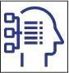 | Lesson Plan Template (Part B)
Grade and Subject | 6th grade STEM class, Origins of Sand |  |  |  | Instructional Time  (min.) | 45 minutes lecture/lab
Lesson Title (Topic) | Around the World in a Grain of Sand
Anchoring Phenomenon  (copy from 1.b) | Our anchoring phenomenon will be driven by routine measurable/visual observation of sand samples (weight, grain size, sphericity, color, possible source rock)
Driving Question  (copy from 1.c) | Why isn’t all sand the same?
Lesson Overview
Lesson Summary  (description) |  |  | Lesson Topics and Student Learning Goals  (copy from 1.f)
Lesson has multiple components:  Working Group selections  10 groups labeled A thru J- Random selection (i.e., reach into bowl draw a “lucky winning letter”!!.. guess what? the other letter is your new class team partner)  Sand sample selection same as picking teammate. Twenty sample every person in class reaches in and “blind” draws a sample.  Google Earth/Google Maps when sample were collected we noted GPS locations so we now will”fly” to those places as well as each location of every groups samples. Heres where the KWL chart comes in to start. Discuss any relevance  Weight collected samples record data, place grains under scope and compare collected natural to Home depot grains use Wentworth scale to approximate size, sorting  Use Wentworth scale and Rock Type photos to determining grain sizes , sorting and color and texture of grains compared to rock types |  |  | Mathematics/physics/information technology  - Review/post formulas for converting from degrees, minutes seconds of latitude/longitude to degrees decimal practice converting both ways.. Use google earth to “fly” to a DD and DMS to see if different.  - Use Wentworth Grain scales to measure and record approximations of grain size  - Weight collected samples  - Attempt discovery source rock type by color and texture. Discuss why, how is this related to weathering, erosion, transport and deposition
Lesson Resources Aligned with Standards
Lesson Resource  (copy from 1.g, sequenced with titles and links) |  |  | Resource Standards Alignment  (copy from 1.d, standards notated, link optional)
Wentworth scales (for grain sizing), https://www.geosupplies.co.uk/acatalog/Leicester-University-Grain-Card-647.html
Celestron Lab series S20 Stereo Microscopes https://.celestron.com%2fproducts%2fcelestron-labs-s20/RK=2/RS=x6qcw3KqW8eeqFjETw7T4zDjn24-

Color photos of Rock types list https://www.sandatlas.org/rock-types/
Teacher Preparation
Student Misconceptions  (potential student ideas that are problematic when engaging in the lesson) |  |  | Scientific Terminology  (vocabulary named once students “figure out” concepts of lesson)
Sand on found only on a beach or playground  Sand is different from rock  Sand is only white |  |  | Weathering , erosion, transport, deposition
Materials Preparation
Student Needs  (activity sheets, data packet, etc.) |  | Group Needs  (lab equipment, group data packets, etc.) |  | Safety & Technology Needs  (unsafe materials, websites cued, etc.)
Template for data recording(provided to each student by instructor)  laptops |  | Dried out collected sand samples  Color photos, microscopes, Wentworth and digital weight scales |  | laptops
Supporting Information
References  (links to cite sources of data, images, websites, etc.) |  |  | Background Reading  (for teachers and/or students)

Complete the 5E Instructional Model section(s) that are relevant to the lesson:

Engage: Interest in a concept is generated and students’ current understanding is assessed.
ACTIVATE interest: Introduce anchoring phenomenon and driving question.
- Engages students in the concepts through a short activity or relevant discussion
- Connects students’ past and present experiences
- Creates interest and generates curiosity
- Uncovers students’ current knowledge and misconceptions
- Initiates students’ investigation into the anchoring phenomenon based on an observation, problem, or question
Phenomenon-based Driving Questions (questions students are likely to ask about the lesson topic)
Lesson Activities (experiment, demonstration, video, visualization, reading, etc., coherently sequenced to help build understanding of PE/standard)
For each activity, provide details of the procedure including timing, teacher guidance, student prompts, strategies for discussions and differentiation, etc.
Formative Assessment (activity sheet, Venn diagram, summary, exit ticket, think-pair-share, etc. to check for understanding of lesson concepts)
Consensus Discussion (claims, evidence, and reasoning on what students figured out in this lesson)
New Questions and Next Steps (student-driven questions, ideas on what to investigate in the next lesson and how to investigate it, etc.)

AND/OR

Explore: Students participate in activities to explore questions related to a concept.
BUILD Knowledge: Learn the science behind concepts.
- Students explore the concepts with others to develop a common set of experiences
- Provides students with one or more actual experiences
- Offers opportunities for creative thinking and skills development
- Students make and record observations and ideas, make connections, and ask questions
- Students usually work in groups
- Teacher acts as coach or facilitator in student-led investigations
Phenomenon-based Driving Questions (questions students are likely to ask about the lesson topic)
Lesson Activities (experiment, demonstration, video, visualization, reading, etc., coherently sequenced to help build understanding of PE/standard)
For each activity, provide details of the procedure including timing, teacher guidance, student prompts, strategies for discussions and differentiation, etc.
Formative Assessment (activity sheet, Venn diagram, summary, exit ticket, think-pair-share, etc. to check for understanding of lesson concepts)
Consensus Discussion (claims, evidence, and reasoning on what students figured out in this lesson)
New Questions and Next Steps (student-driven questions, ideas on what to investigate in the next lesson and how to investigate it, etc.)

AND/OR

Explain: Students construct their understanding of a concept and develop evidence-based explanations.
DEVELOP Concepts: Research information using real-world data.
- Develops students’ explanation for the concepts they have been exploring with teacher providing supporting guidance
- Students describe their observations and come up with explanations
- Students listen critically to each other’s explanations
- Students learn to apply and interpret evidence
- Develops students’ academic vocabulary by applying scientific terms once students have figured out the lesson concepts
- Teacher guides students’ reasoning, asks appropriate questions, and directs students to additional supporting resources
Phenomenon-based Driving Questions (questions students are likely to ask about the lesson topic)
Lesson Activities (experiment, demonstration, video, visualization, reading, etc., coherently sequenced to help build understanding of PE/standard)
For each activity, provide details of the procedure including timing, teacher guidance, student prompts, strategies for discussions and differentiation, etc.
Formative Assessment (activity sheet, Venn diagram, summary, exit ticket, think-pair-share, etc. to check for understanding of lesson concepts)
Consensus Discussion (claims, evidence, and reasoning on what students figured out in this lesson)
New Questions and Next Steps (student-driven questions, ideas on what to investigate in the next lesson and how to investigate it, etc.)

AND/OR

Elaborate: Students deepen and expand their understanding by applying their understanding in new contexts.
APPLY Learning: Utilize information in new ways.
- Extends students’ understanding or applies what they have learned in a new setting
- Students use the information they have gained to propose solutions and extend their learning to new situations
- Teacher supports students in broadening their understanding and extend ideas to other situations so they can draw broader conclusions beyond their experiment or investigation
Phenomenon-based Driving Questions Extended/Applied in a New Context (questions students are likely to ask about the lesson topic)
Lesson Activities (experiment, demonstration, video, visualization, reading, etc., coherently sequenced to help build understanding of PE/standard)
For each activity, provide details of the procedure including timing, teacher guidance, student prompts, strategies for discussions and differentiation, etc.
Formative Assessment (activity sheet, Venn diagram, summary, exit ticket, think-pair-share, etc. to check for understanding of lesson concepts)
Consensus Discussion (claims, evidence, and reasoning on what students figured out in this lesson)
New Questions and Next Steps (student-driven questions, ideas on what to investigate in the next lesson and how to investigate it, etc.)

AND/OR

Evaluate: Students and teachers have opportunities to assess students’ understanding of a concept.
DEMONSTRATE Ability: Write, illustrate, create, etc. artifacts that accurately describe knowledge gained.
- Students have the opportunity to demonstrate understanding of skills and concepts, and evaluate their own progress
- Teacher evaluates students’ understanding and progress, as well as their own instructional practice, and may implement alternative assessment strategies
- Enables adjustment of misconceptions, reinforces students’ understanding of the PE concepts in greater depth
Phenomenon-based Driving Questions (questions about the lesson topic)
Skills Learning Performance (SEPs) Goals (assess student skills related to the lesson)
Formative Assessment (quiz, test, report, presentation, poster, video, model, etc. to demonstrate students’ understanding about the PEs/standards)
Content Learning Performance (DCIs, CCCs) Goals (assess student mastery of lesson content)
Summative Assessment (quiz, test, report, presentation, poster, video, model, etc. to demonstrate students’ understanding about the PEs/standards)

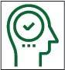 | Step 4: Lesson Instruction and Reflection
Lesson Notes During Instruction
- What modifications (instruction, timing, etc.) were made or are needed for the lesson, activities, or resources?
- Which parts of the lesson, activities, or resources were or need to be changed?
- How effective (or ineffective) were the lesson, activities, or resources for student learning?

Review and Revise Post-Instruction
- Which parts of the lesson were a success?
- What were some challenges about the lesson?
- How could the lesson be changed or improved?

